**Progress Report: O&W Rail Trail, Town of Wawarsing, Department of Corrections section: March 2018**

The Town of Wawarsing highway department has completed all, grubbing, retaining walls, and major fill areas on the rail trail section. The large fill area, shown in images #’s adjacent to the old canal bed south of Institution road has received many tons of fill to obtain the required trail bed width. Serendipitously, the Department of Corrections has been excavating on adjacent lands that they own for a separate construction project, and the rail trail project has been able to obtain thousands of tons of fill for trucking cost by town employees. Wet areas adjacent to the trail bed have been monitored over the winter and culverts and additional fill and drainage, will be added in spring of 2018 before the team begins surfacing operations. The town has taken delivery of and paid for the 40 plus signs, and the hundreds of feet of cedar fencing mandated by DOCCS in the easement agreement with the Town.

The town has determined through correspondence with the County’s Commissioner of Public Works, that signage and a pedestrian/bicycle crosswalk can be installed on the Town owned section of Institution Road at the rail trail intersection. Construction will continue in spring of 2018.The Town’s highway Superintendent anticipates completing most of the surfacing this construction season.

At this point in time the town formally requests an extension on the contract with UCEDA to June of 2019 to allow for high quality completion of the rail trail project in conjunction with completing several other transportation priorities in the Town’s transportation network.

**Image Key:**

#1 Looking south at cleared area through pine plantation adjacent to convict cemetery

#2 Looking north near Institution road: cleared and graded area

#3 Area of substantial fill adjacent to old D&H canal bed and O&W rail museum

#4 Area of substantial fill immediately north of #3

#5 Looking south at filled, retained, graded area near bridge crossing, and sewer plant

#6 Looking north at same area as #5

#7 Cleared and graded area north of cemetery

#1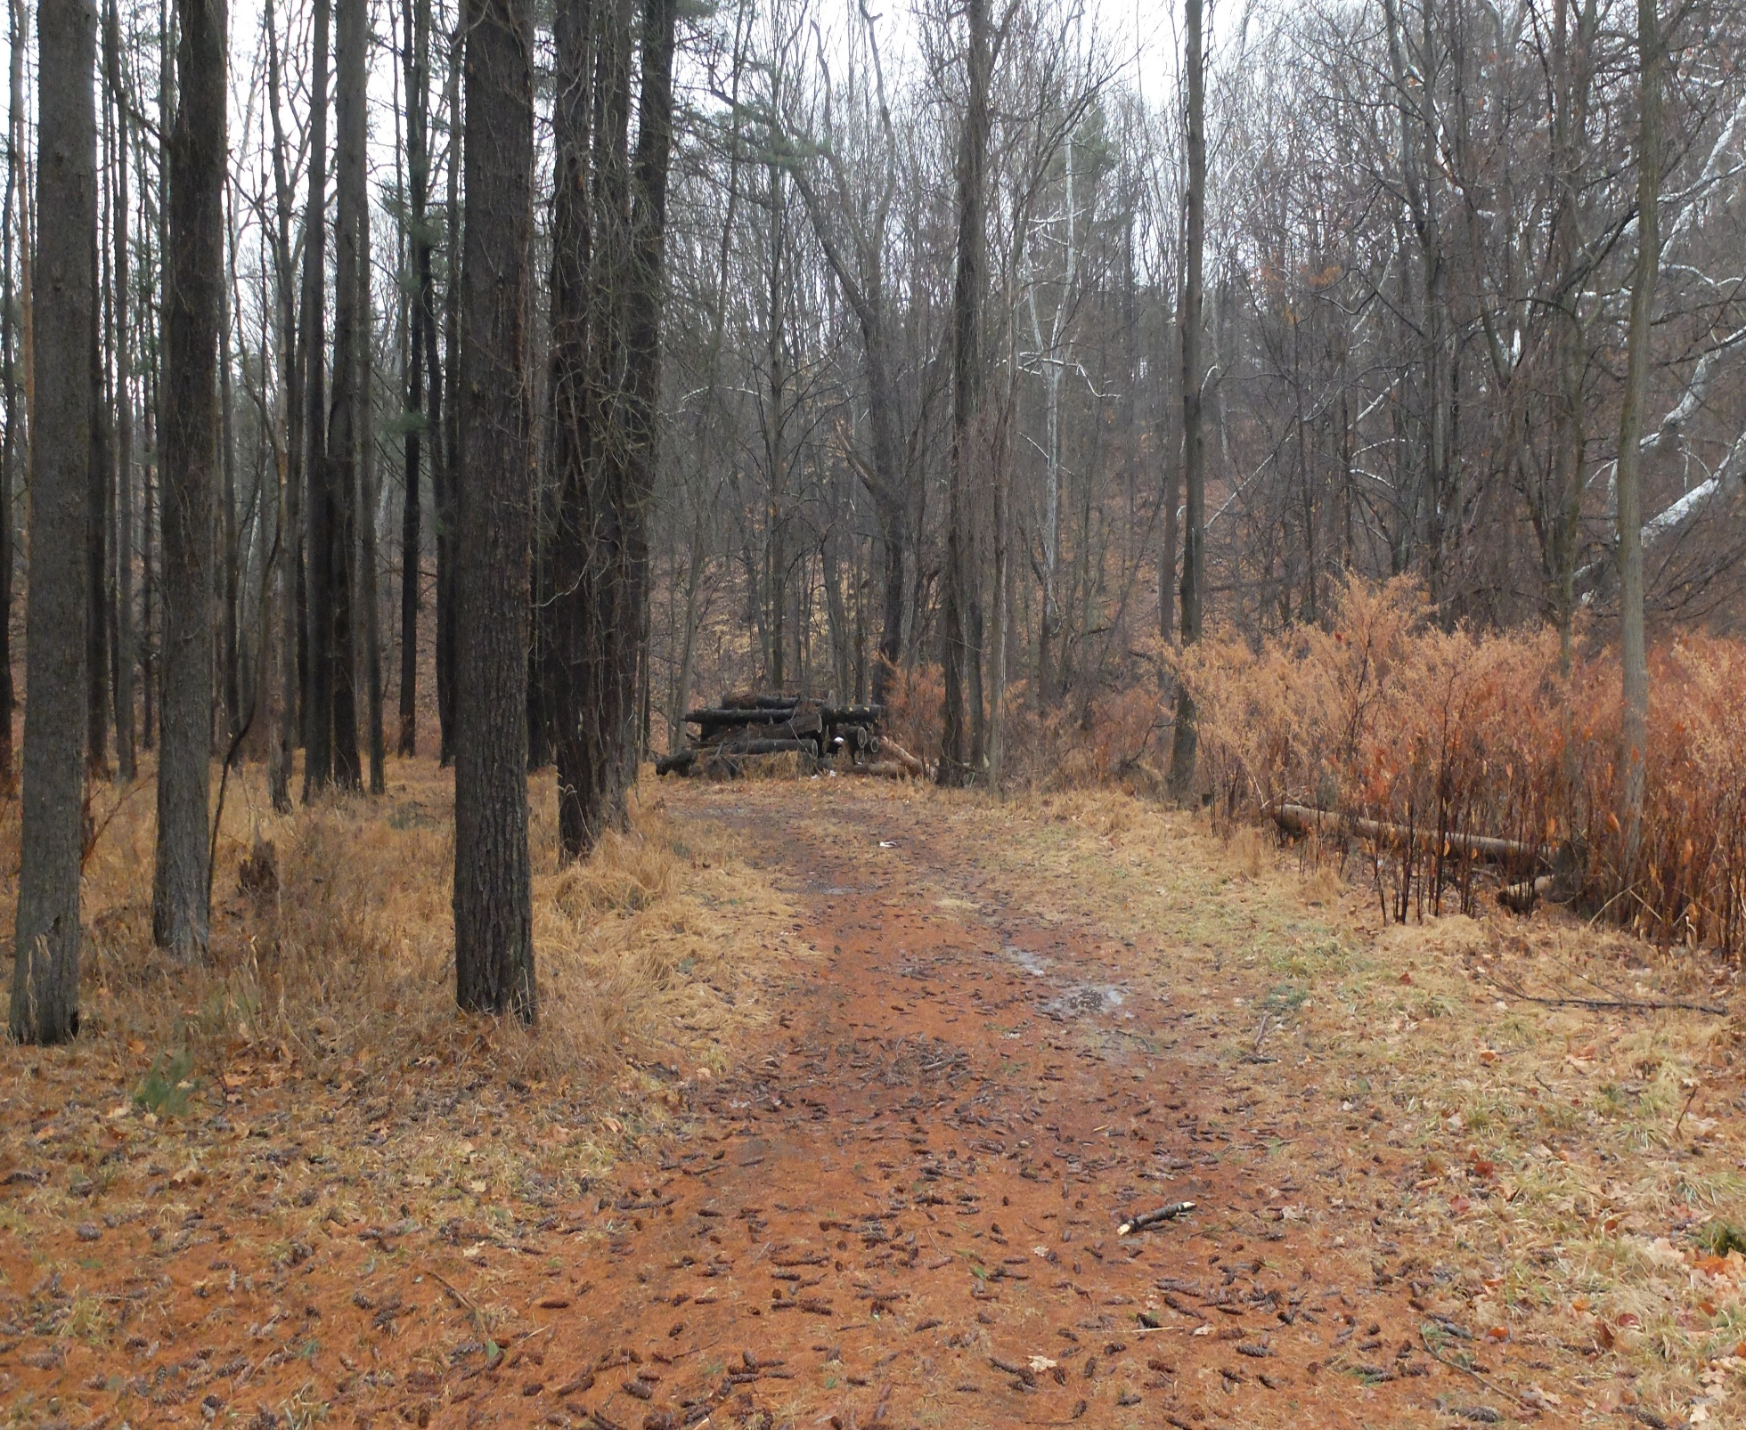

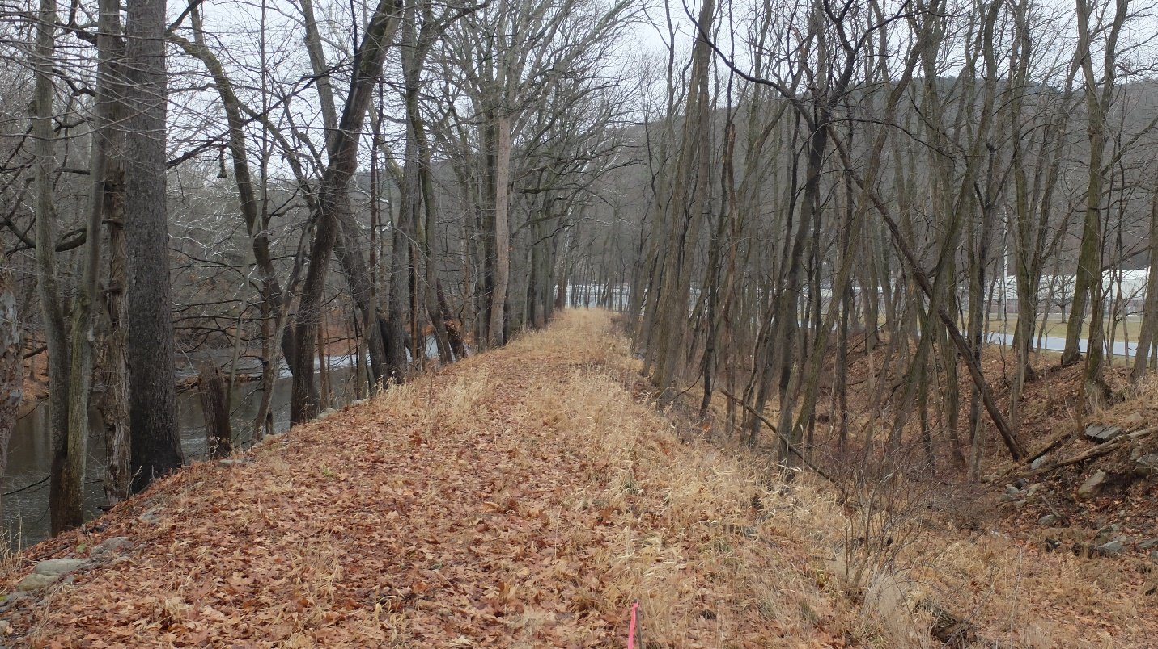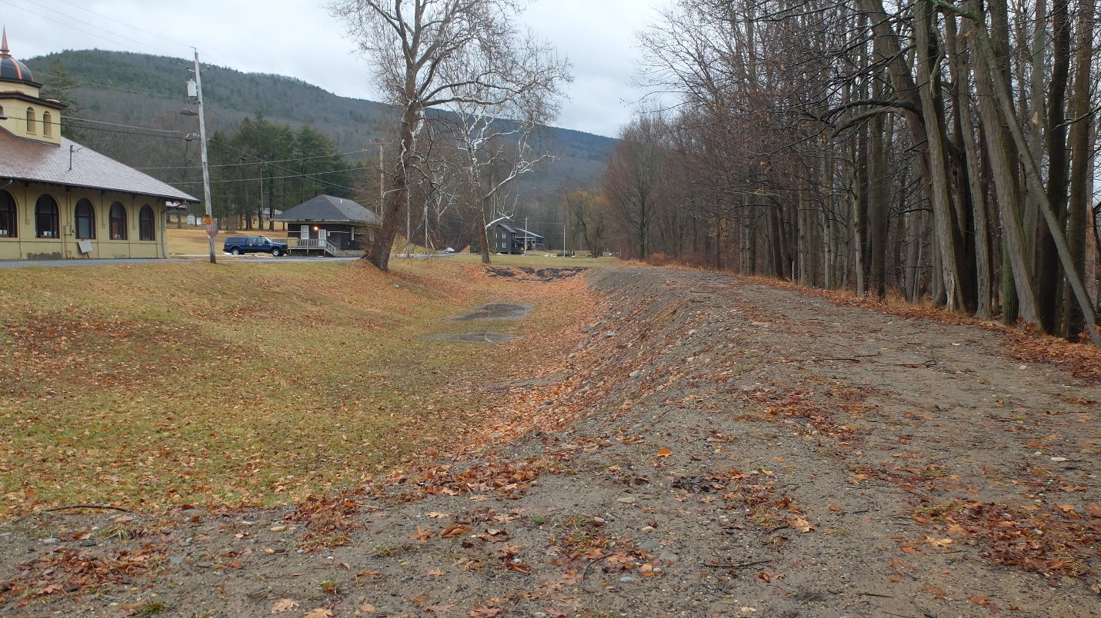

#2and #3

#4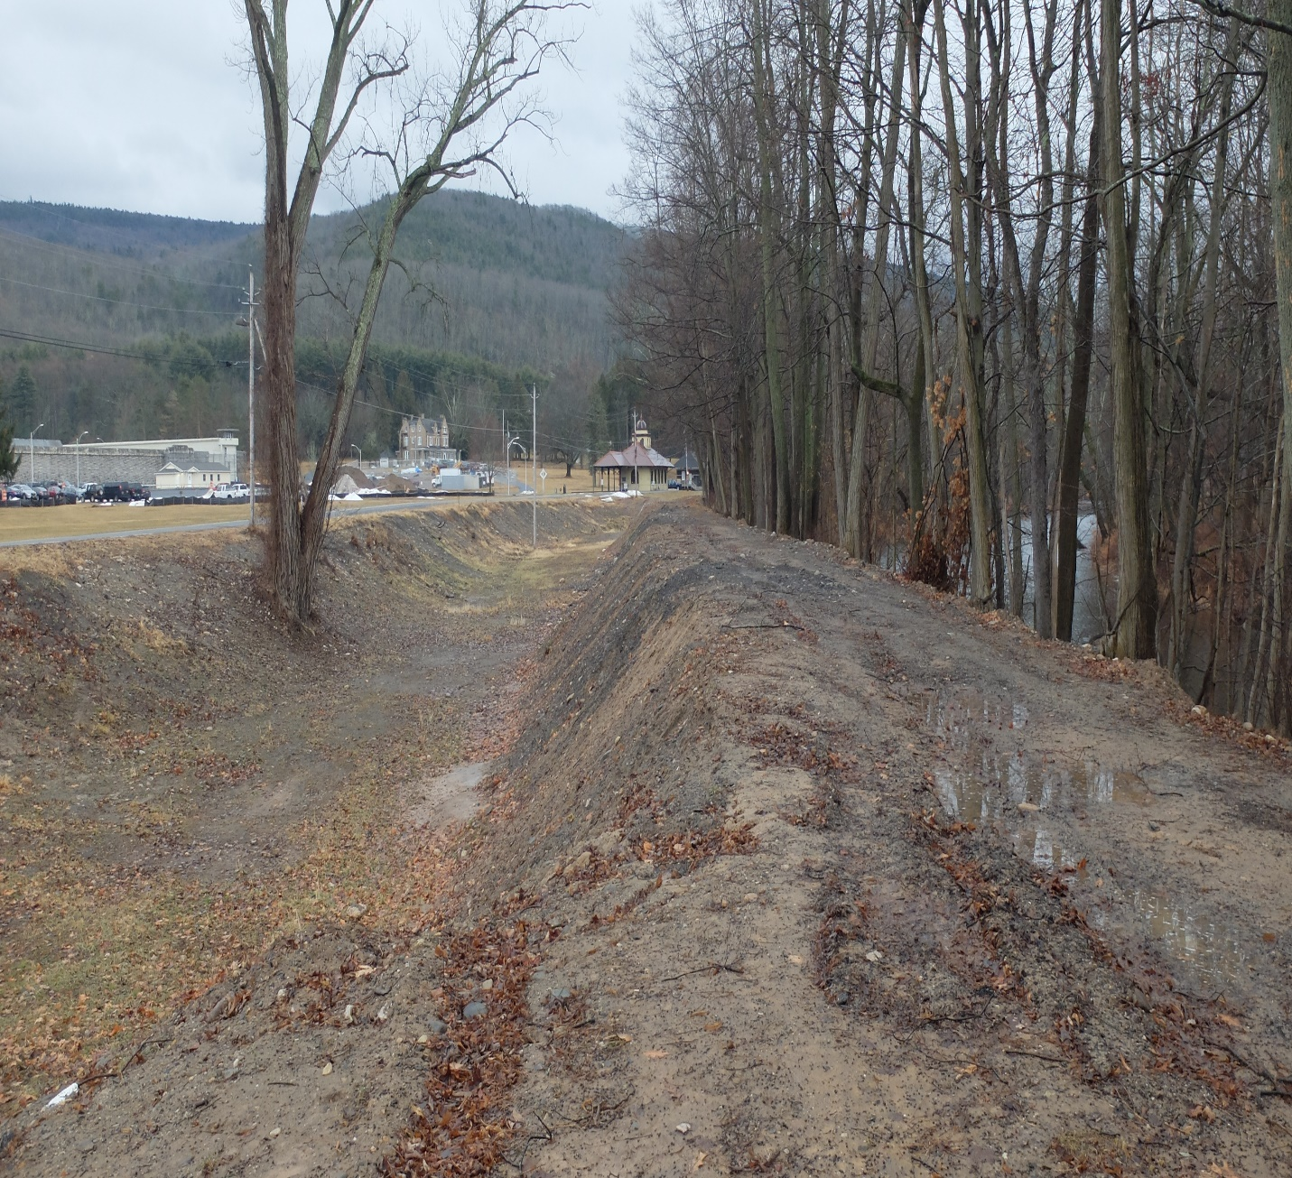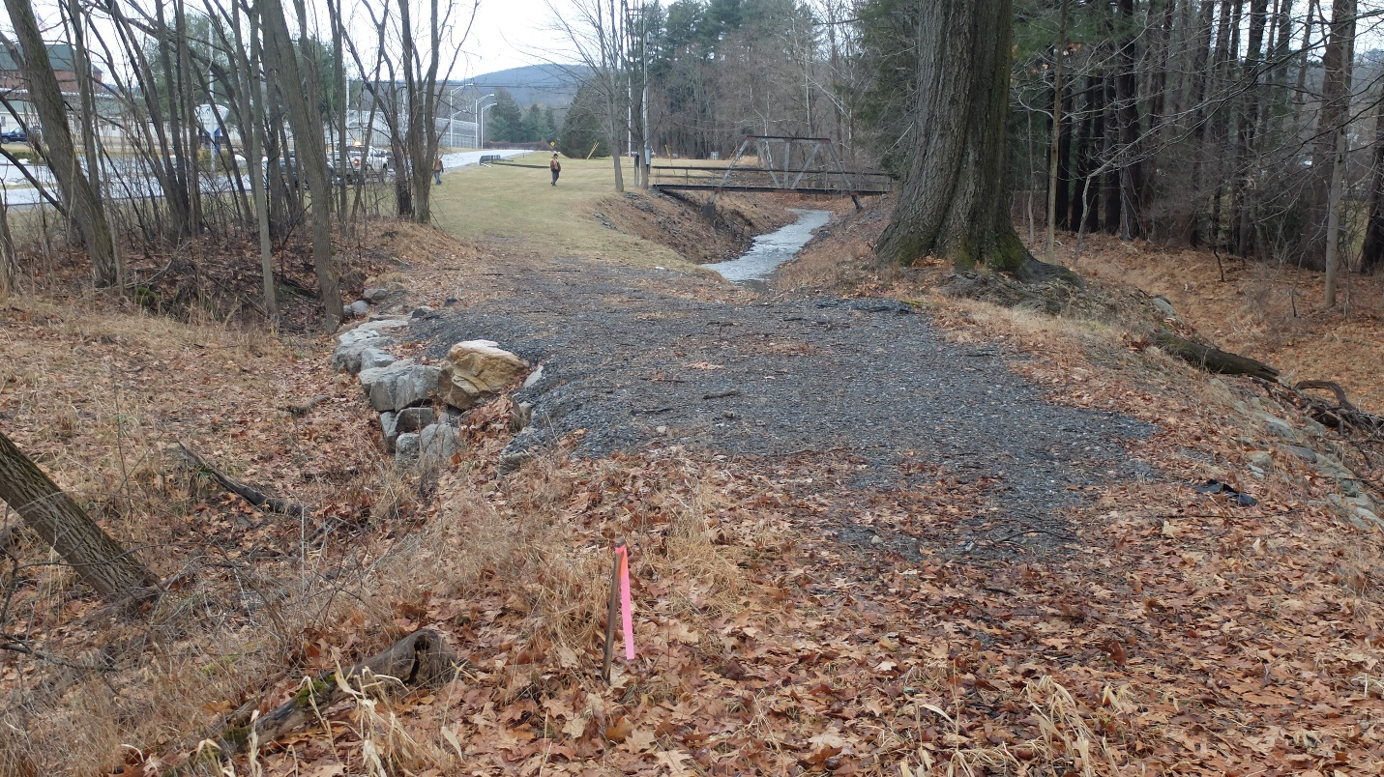

#5 and #6

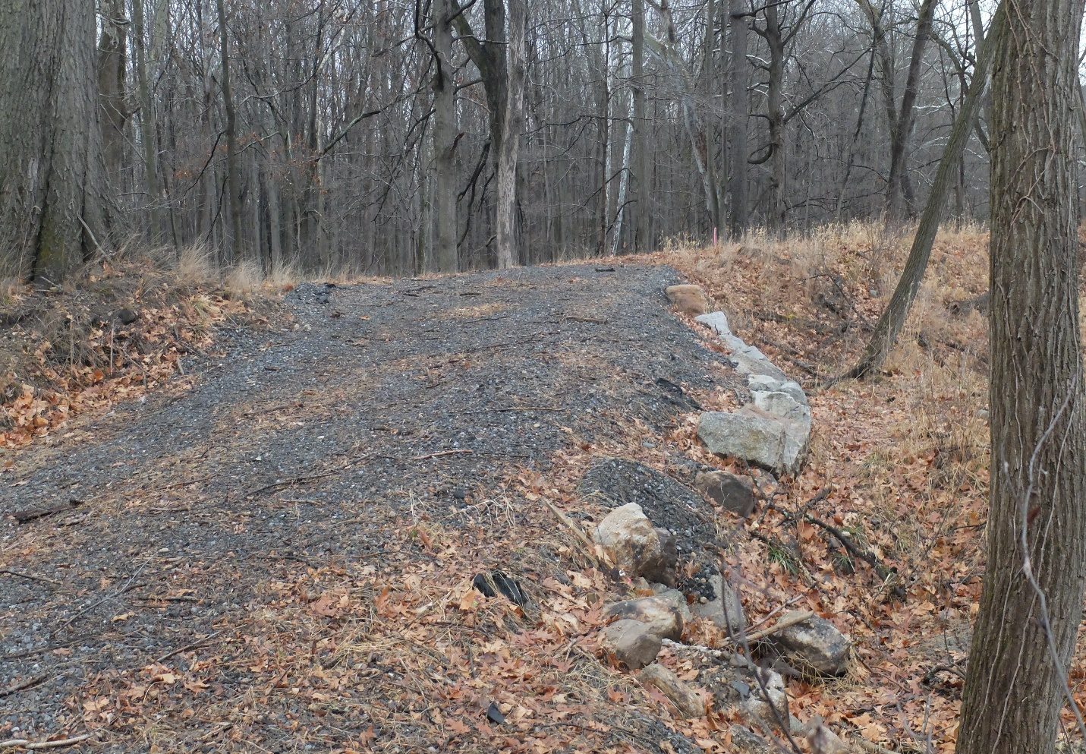

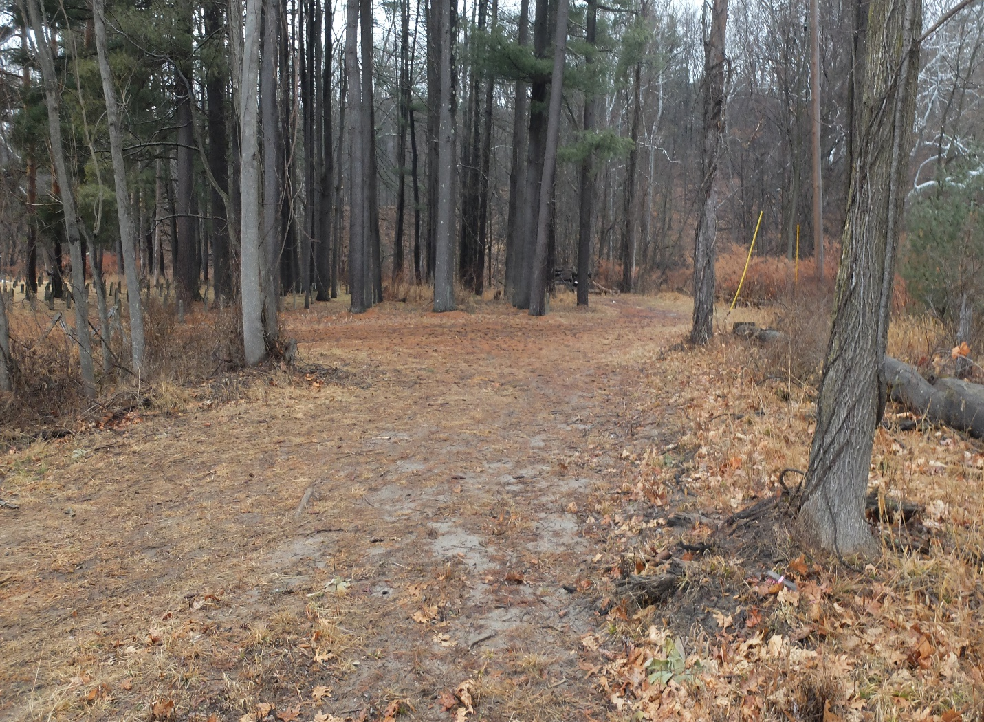

#7